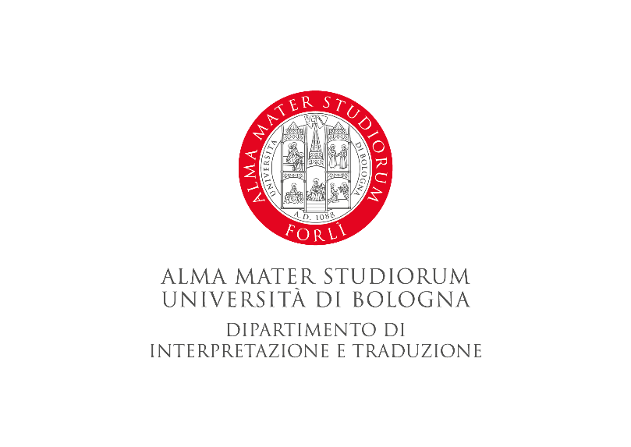

Monday, 16 October 2023 - Teaching Hub, viale Corridoni, 20 - Forlì

How to apply to a Master or a PHD program in a university in the United States,
and how to acclimatize to campus life
9.00-10.30, aula TH7

‘Translating’ academic research
for the worlds of politics and the media
13.30-15.00, aula TH 7

Francesca Gaiba (PhD, CPRA)
Research Professor and Sr. Director of Operations and Outreach
Institute for Policy Research
Northwestern University (Evanston, IL - USA)

